Acceptance Testing
UAT Execution & Report Submission
Date | 14 October 2026
Team ID
Project Name | Automated Network Request Management System
Maximum Marks | 4 Marks

1. Purpose of Document
The purpose of this document is to briefly explain the test coverage and open issues of the Automated Network Request Management System project at the time of the release to User Acceptance Testing (UAT).
2. Defect Analysis
This report summarizes test execution across 8 functional scenarios. 100% of test cases passed. Three minor configuration defects identified during initial testing were analyzed, remediated, and closed.
3. Test Execution Verification:
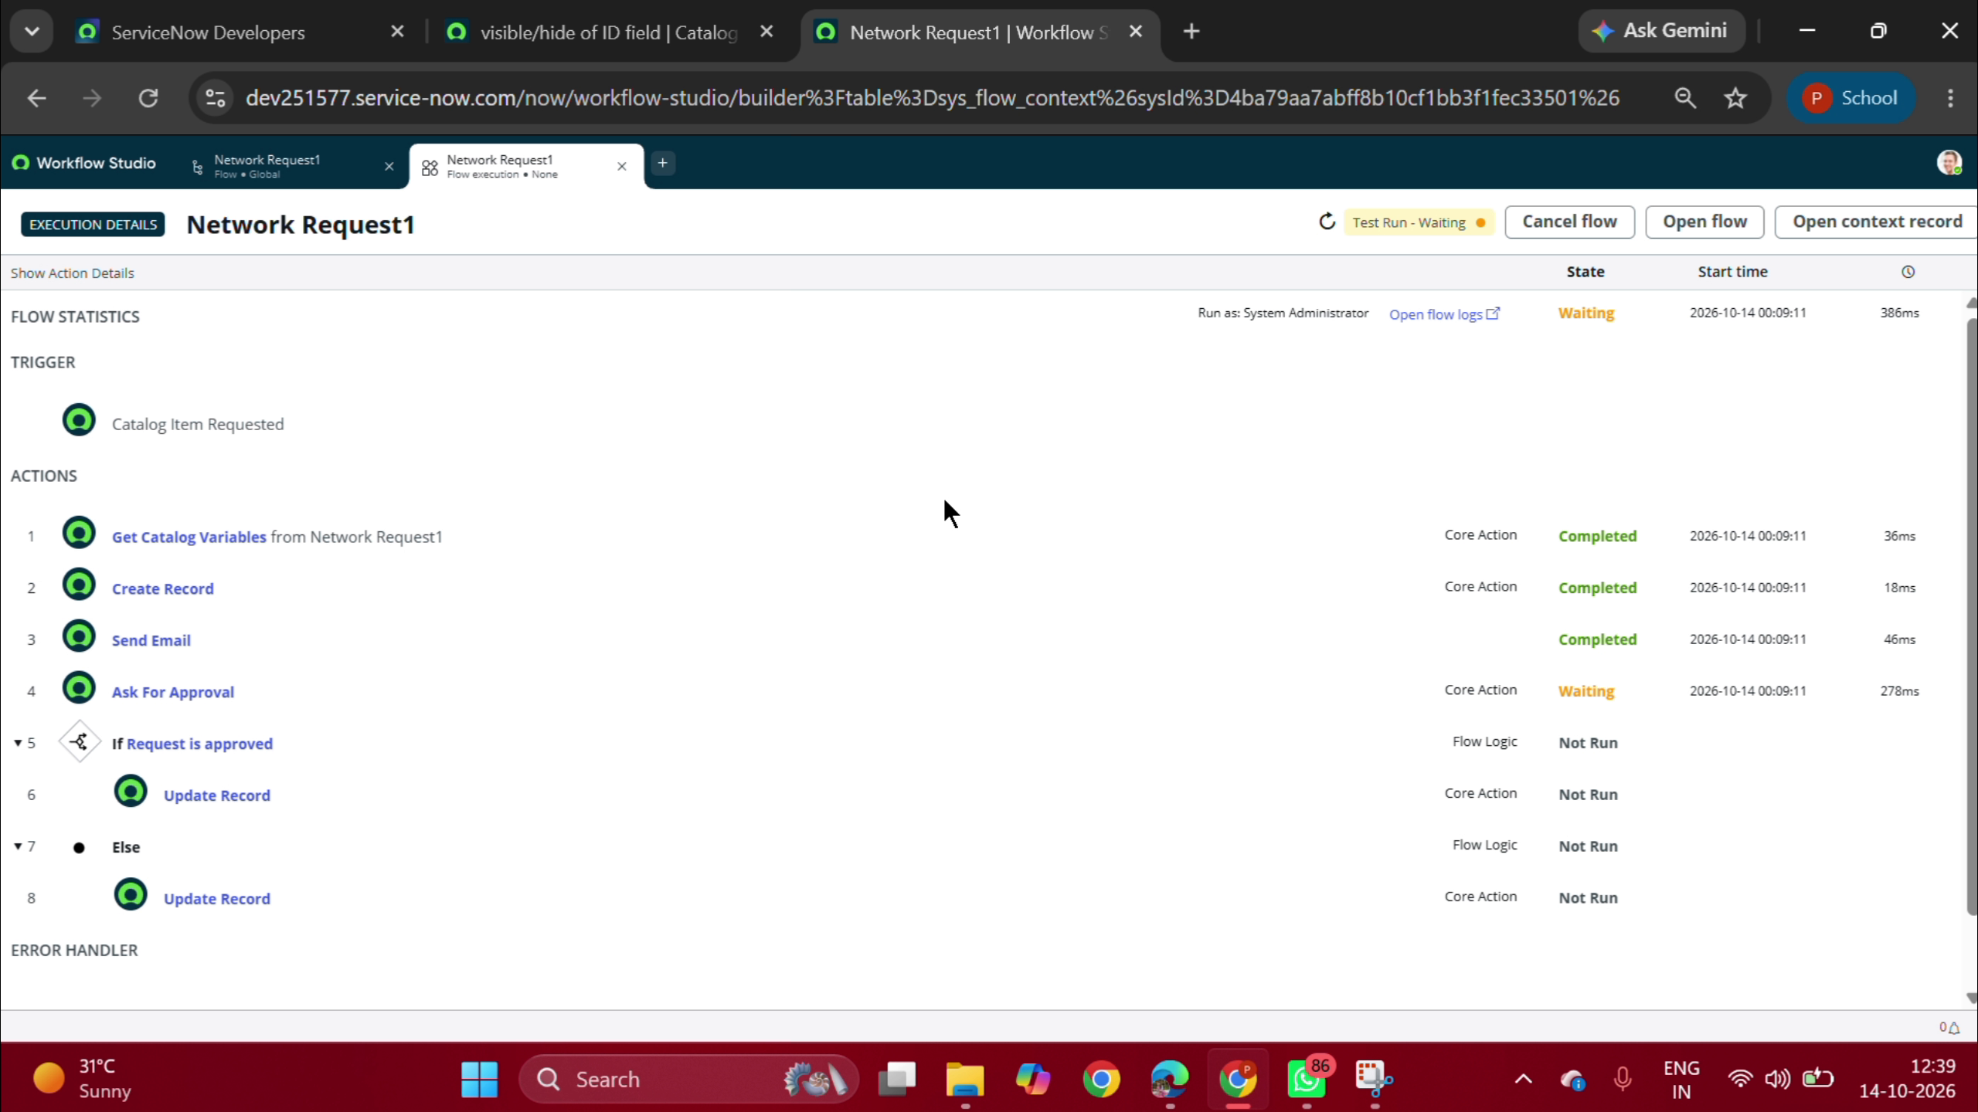
Figure 5.1: Live Flow Execution Verification Showing Completed Core Actions
4. Sign-off
The Automated Network Request Management System is approved and signed off as meeting all functional and non-functional requirements.
Tester / Developer: Pooja Reddy
Date: 14 October 2026
Result: 100% PASS - Ready for Production Deployment.

